**“Smart Cart”**

**A Project Report**

**Submitted in the partial fulfilment of the requirements for the award of the degree of**

**Bachelor of Technology in**

**Department of Mechanical Engineering By**

**190070039 – Kare Rohit**

**190070049 – Bindu Saranya**

**190070084 – Puneet Gurnani**

**190070117 – Y.Manoj Dikshith**



Declaration

The Project Report entitled “**Smart Cart**” is a record of bona fide work of submitted in partial fulfilment for the award of B. Tech in mechanical engineering to the K L University. The results embodied in this report have not been copied from any other department/university/institute

**190070039 – Kare Rohit**

**190070049 – Bindu Saranya**

**190070084 – Puneet Gurnani**

**190070117 – Y.Manoj Dikshith**

**Certificate**

This is to certify that the (Design For Physical Systems Project) Report entitled “**Smart Cart**” is being submitted by 190070039 – Kare Rohit, 190070049 – Bindu Saranya ,190070084 – Puneet Gurnani ,190070117 – Y.Manoj Dikshith, submitted in partial fulfilment for the award of B. Tech in Mechanical to the K L University is a record of Bonafide work carried out under our guidance and supervision.

The results embodied in this report have not been copied from any other departments/ University/Institute.

## Signature of the Co-Supervisor Signature of the Supervisor

Name and Designation Name and Designation

**Signature of the HOD Signature of the External Examiner**

**Acknowledgement**

I also wish to extend my thanks to **T.Easwara Rao sir** and other faculties for guiding and providing the knowledge related to machinery and processes.

I express the sincere gratitude to our Mechanical Head of the Department

**Dr. D. V. A. Rama Sastry** for his Admission towards our academic growth.

Finally, it is pleased to acknowledge the indebted to all those who devoted themselves directly or indirectly to make this project success.

|  |  |  |
| --- | --- | --- |
| S.no | Name | id no |
| 1. | Kare Rohit | 190070039 |
| 2. | Bindu Saranya | 190070049 |
| 3. | Puneet Gurnani | 190070084 |
| 4. | Yenni Manoj Dikshith | 190070117 |

# Abstract

Generally in shopping malls , or in show rooms there will be billing counters through which the payment will be done for the corresponding products that are purchased by customers , or with the help of the smart cart in which the customers can directly drop the products in that particular trolley or cart through which the customers who have dropped the products will be automatically getting the details of that particular product such as price , brand , size ,etc. With the help of the display board inserted in the cart. There will be also card swiping machine for completing the payment transaction without directly proceeding to the billing counters.

# Introduction

The main purpose of this paper is to provide automated billing system using RFID and ZigBee communication.Each product of shopping mall, super markets will be supplied with an RFID tag, to identify its type. Every cart contains PID (Product Identification Device). Specifically, PID contains a microcontroller, LCD, an RFID reader, EEPROM, and ZigBee module.The centralized database will give product recommendation and information about the product on the LCD screen present on the shopping cart, which will help the customer in buying products. LCD can display characters, numbers, and graphics . LCD show the running bill.The purpose of this paper is to provide an automatic billing system by using RFID and ZigBee to avoid the queue and save time in malls and super markets & to give product recommendation and information with Anti-Theft.

**About the project:**

To design a cart which displays the total bill of the items placed in it in the LCD

**Software used:** Aurdino UNO

**Assembly & Components: -** Cart body,RFID tag,Zigbee module,PID (Product Identification Device) comprises of microcontroller, LCD , RFID reader,EEPROM.

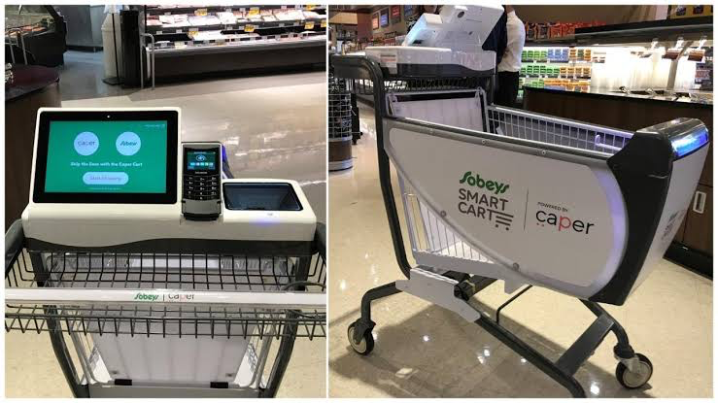

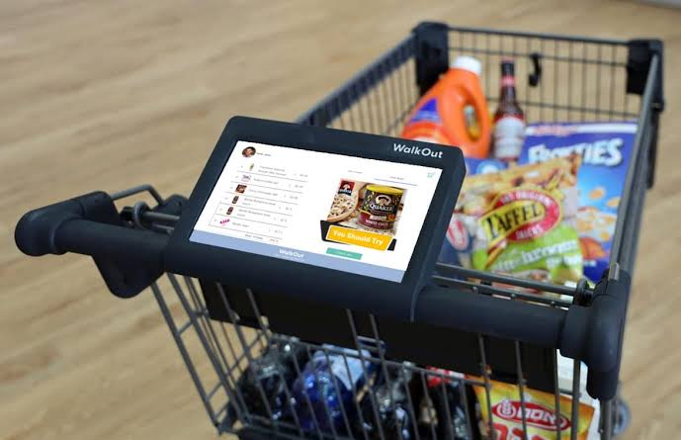

**Working:**

it displays the total bill of the items placed in the cart on the LCD integrated with it.

Body: The body of the normal cart is taken to integrate hardware elements with it.

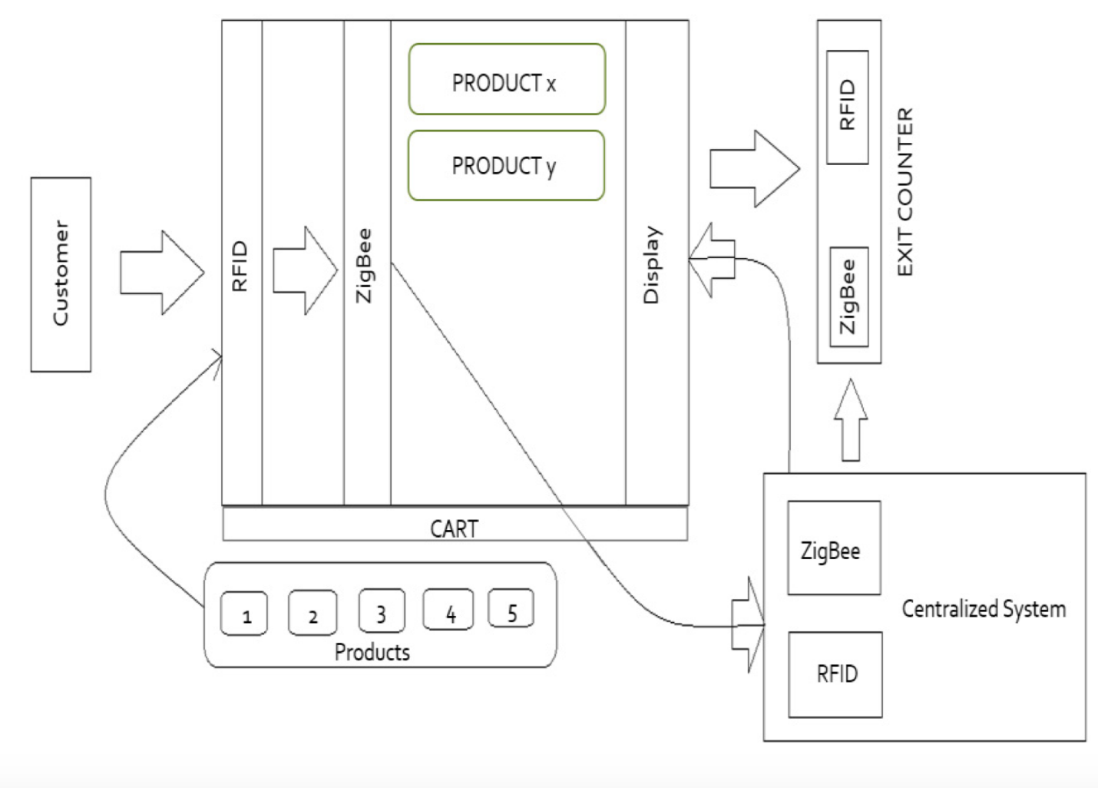

# Software's used

Arduino IDE:

* Arduino Integrated Development Environment
* The open-source Arduino Software (IDE) makes it easy to write code and upload it to the board. It runs on Windows, Mac OS X, and Linux. To analyse the manipulator

# Hardware requirements

## Arduino uno:

* Arduino UNO is a low-cost, flexible, and easy-to-use programmable open-source microcontroller board that can be integrated into a variety of electronic projects. This board can be interfaced with other Arduino boards, Arduino shields, Raspberry Pi boards and can control relays, LEDs, servos, and motors as an output.

## RFID Tag:

* The Radio-frequency identification (RFID) uses [electromagnetic fields](https://en.wikipedia.org/wiki/Electromagnetic_field" \o "Electromagnetic field) to automatically [identify](https://en.wikipedia.org/wiki/Automatic_identification_system" \o "Automatic identification system) and [track](https://en.wikipedia.org/wiki/Tracking_system" \o "Tracking system) tags attached to objects. An RFID system consists of a tiny radio [transponder](https://en.wikipedia.org/wiki/Transponder" \o "Transponder), a [radio receiver](https://en.wikipedia.org/wiki/Radio_receiver" \o "Radio receiver) and [transmitter](https://en.wikipedia.org/wiki/Transmitter" \o "Transmitter). When triggered by an electromagnetic interrogation pulse from a nearby RFID reader device, the tag transmits digital data, usually an [identifying inventory number](https://en.wikipedia.org/wiki/Identifier" \o "Identifier), back to the reader. This number can be used to track [inventory](https://en.wikipedia.org/wiki/Inventory" \o "Inventory) goods

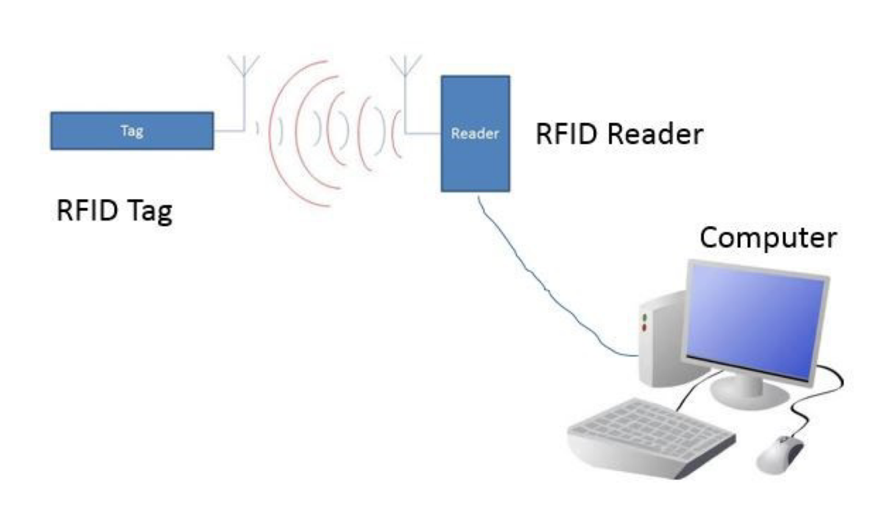

## Zigbee Module:

* Zigbee is a standards-based wireless technology developed to enable low-cost, low-power wireless machine-to-machine and internet of things (IoT) networks. Zigbee is for low-data rate, low-power applications and is an open standard.

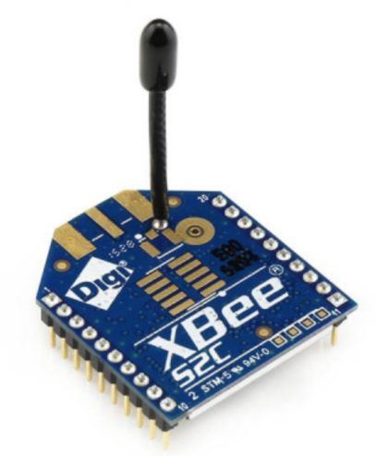

## PID Controller:

* A PID controller is an instrument used in industrial control applications to regulate temperature, flow, pressure, speed and other process variables.

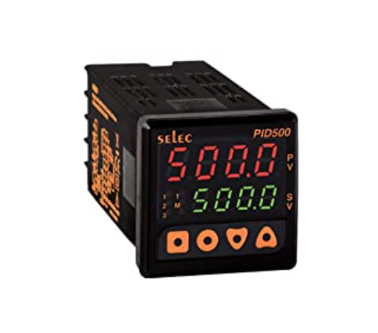

**Aurdino UNO:**

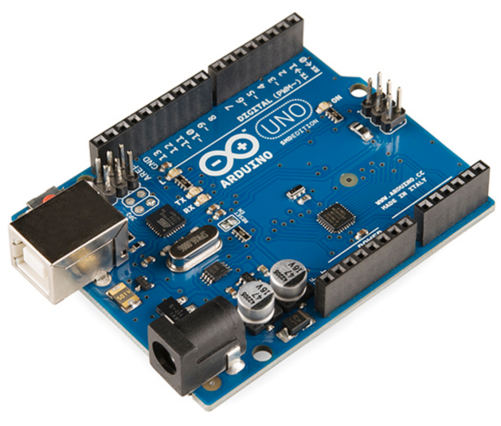

**Micro-controller:**

Microcontroller is a compressed micro computer manufactured to control the functions of embedded systems in office machines, robots, home appliances, motor vehicles, and a number of other gadgets.

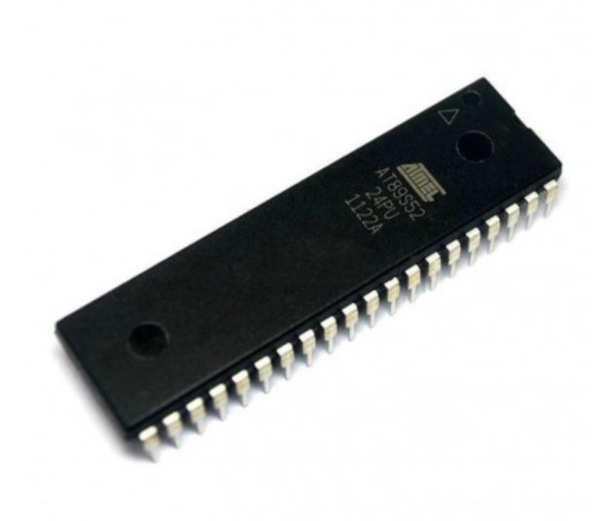

**EEPROM:**

EEPROM stands for electrically erasable programmable read-only memory. It is a non-volatile flash memory device, that is, stored information is retained when the power is removed. EEPROM generally offers excellent capabilities and performance.

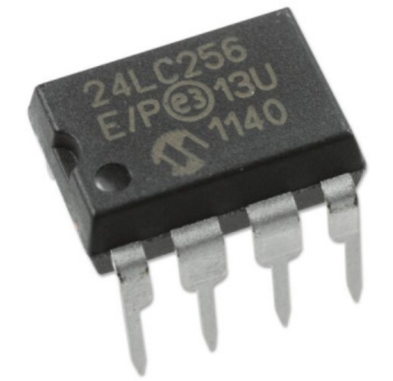

**Format of Data stored in Main data base:**

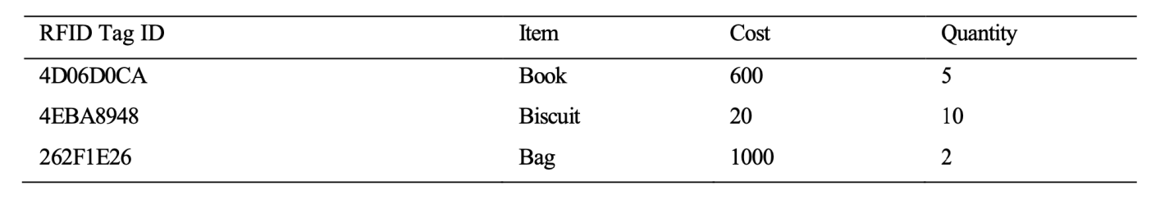

**Format of Data displayed in LCD:**

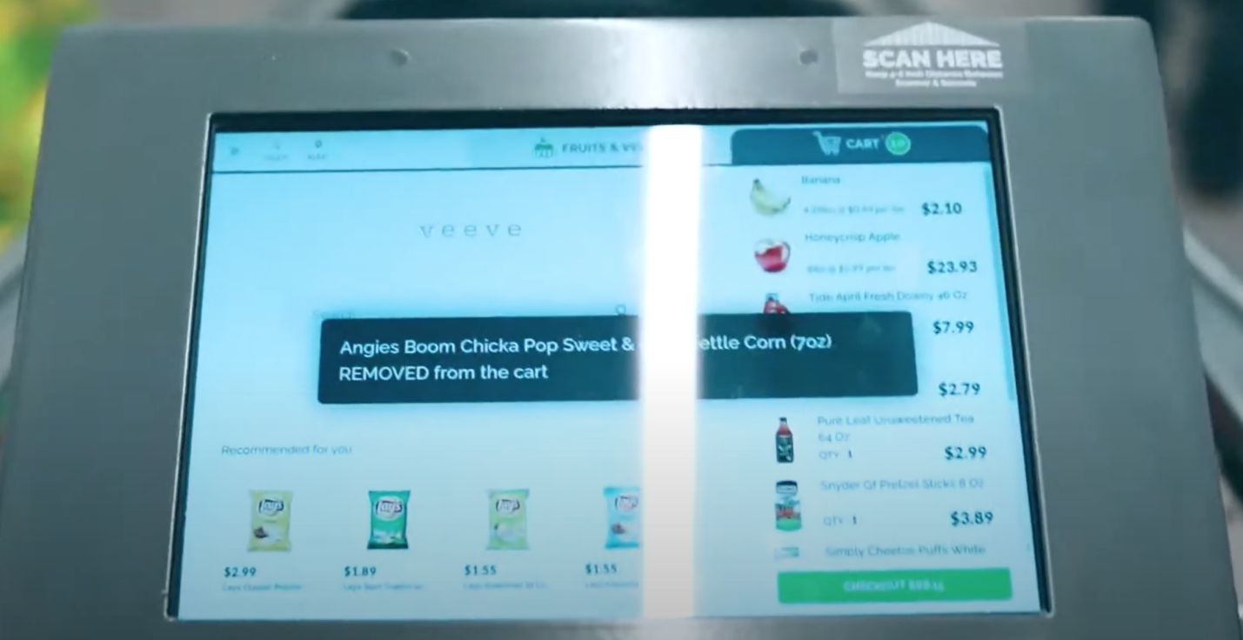

**Aurdino codes for hardware elements:**

**RFID reader:**

#include <SPI.h>

#include <MFRC522.h>

#define SS_PIN 10

#define RST_PIN 9MFRC522 mfrc522(SS_PIN, RST_PIN);

void setup()

{

Serial.begin(9600);

SPI.begin();

mfrc522.PCD_Init();

Serial.println("Approximate your card to the reader...");

Serial.println();

}

void loop()

{

if ( ! mfrc522.PICC_IsNewCardPresent())

{

return;

}

if ( ! mfrc522.PICC_ReadCardSerial())

{

return;

}

Serial.print("UID tag :");

String content= ""; byte letter;

for (byte i = 0; i < mfrc522.uid.size; i++)

{

Serial.print(mfrc522.uid.uidByte[i] < 0x10 ? " 0" : " "); Serial.print(mfrc522.uid.uidByte[i], HEX); content.concat(String(mfrc522.uid.uidByte[i] < 0x10 ? " 0" : " ")); content.concat(String(mfrc522.uid.uidByte[i], HEX)); } Serial.println();

Serial.print("Message : ");

content.toUpperCase();

if (content.substring(1) == "BD 31 15 2B")

{

Serial.println("Authorized access");

Serial.println();

delay(3000);

}

else

{ Serial.println(" Access denied");

delay(3000);

}

}

**EEPROM reader:**

#include <EEPROM.h>

int address = 0;

13byte value;

void setup()

{

Serial.begin(9600);

while (!Serial)

{

;

}

}

void loop()

{

value = EEPROM.read(address);

Serial.print(address);

Serial.print("\t");

Serial.print(value, DEC);

Serial.println();

}

address = address + 1;

if (address == EEPROM.length())

{

address = 0;

}

delay(500);

}

**ZIGBEE Module:**

int led = 13;  
int received = 0;  
int i;  
void setup() {  
  Serial.begin(9600);   
  pinMode(led, OUTPUT);  
}  
   
void loop() {  
  if (Serial.available() > 0) {  
received = Serial.read();  
    
    if (received == 'a'){  
    digitalWrite(led, HIGH);  
    delay(2000);  
    digitalWrite(led, LOW);  
    }  
     else if (received == 'b'){  
      for(i=0;i<5;i++){  
    digitalWrite(led, HIGH);  
    delay(1000);  
    digitalWrite(led, LOW);  
    delay(1000);  
    }  
  }   
}  
}

**PID Controller:**

double kp = 2

double ki = 5

double kd = 1

unsigned long currentTime, previousTime;

double elapsedTime;

double error;

double lastError;

double input, output, setPoint;

double cumError, rateError;

void setup(){

setPoint = 0;

}

void loop()

{

input = analogRead(A0);

output = computePID(input);

delay(100);

analogWrite(3, output);

PID value

}

double computePID(double inp){

currentTime = millis();

elapsedTime = (double)

(currentTime - previousTime);

error = Setpoint - inp;

cumError += error * elapsedTime;

rateError = (error - lastError)/elapsedTime;

double out = kp*error + ki*cumError + kd*rateError; //PID output

lastError = error;

previousTime = currentTime;

return out;

PID output

}

**TOTAL COST OF THE CART**

|  |  |  |
| --- | --- | --- |
| S.NO | ITEM | PRICE |
| 1 | ZIGBEE MODULE | Rs.2200 |
| 2 | RFID READER | Rs.285 |
| 3 | RFID TAG | Rs.10 |
| 4 | MICROCONTROLLER | Rs.85 |
| 5 | LCD (7 INCH touch display) | Rs.3695 |
| 6 | PID CONTROLLER | Rs.2790 |
| 7 | AURDINO | Rs.780 |
| 8 | EEPROM | Rs.60 |
| 9 | NORMAL SHOPPING CART | Rs.2000 |
| 10 | ASSEMBLY COST | Rs.1000 |
|  | **TOTAL COST** | **RS.12,905** |

**REFERENCES**

<https://www.sciencedirect.com/science/article/pii/S1877050916002386>

<https://www.youtube.com/watch?v=PbP8IbX3c-A>

<https://www.youtube.com/watch?v=KG8u8UtwgYg>

# Conclusion

we conclude that our SMART CART helps for centralized automated billing system.It also assures avoiding the queue and save time in malls and super markets & to give product recommendation and information with Anti-Theft.